**A**

**MINI PROJECT REPORT**

**on**

# “Pharmacy Management System ”

**BE(AI&DS)-III Sem**

**By**

**SOHAIL SHARIFF (160120747053)**

**&**

**K SREEKAR REDDY (160120747054)**

**Under the guidance of**

**Ms. RAMALAXMI mam**

**Assistant Professor**

**IT Department**



**DEPARTMENT OF INFORMATION TECHNOLOGY CHAITANYA BHARATHI INSTITUTE OF TECHNOLOGY (A)**

**(Affiliated to Osmania University; Accredited by NBA(AICTE) and NAAC(UGC), ISO Certified 9001:2015)**

**KOKAPET(V), GANDIPET(M), RR District HYDERABAD - 75**

**Website:** [**www.cbit.ac.in**](http://www.cbit.ac.in/)



This is to certify that the project work entitled “**PHARMACY MANAGEMENT**

**SYSTEM**” submitted to CHAITANYA BHARATHI INSTITUTE OF

TECHNOLOGY, in partial fulfilment of the requirements for the completion of Mini Project-I of III Semester B.E. in Artificial Intelligence and Data Science, during the Academic Year 2021-2022, is a record of original work done by **SOHAIL SHARIFF(160120747053) and K SREEKAR REDDY(160120747054)** during the period of study in the Department of IT, CBIT, HYDERABAD, under our guidance.

|  |  |
| --- | --- |
| **Project Guide** | **Head of the Department** |
| **Ms. RAMALAXMI** | **Dr.K.Radhika** |
| Assistant Professor, Dept. of IT, | Professor, Dept. of IT, |
| CBIT, Hyderabad. | CBIT, Hyderabad. |

# ACKNOWLEDGEMENTS

We would like to express our heartfelt gratitude to **Ms RAMALAXMI**, our project guide, for her invaluable guidance and constant support, along with her capable instruction and persistent encouragement.

We are grateful to our Head of Department, **Dr.K.Radhika**, for her steady support and for the provision of every resource required for the completion of this project.

We would like to take this opportunity to thank our Principal, **Dr.P.Ravinder Reddy**, as well as the Management of the Institute, for having designed an excellent learning atmosphere.

Our thanks are due to all members of the staff and our lab assistants for providing us with the help required to carry out the groundwork of this project.

# ABSTRACT

This project is illustrates the designing and implementation of a Pharmacy Management System with stock alert system. The primary aim of is to improve accuracy and enhance safety and efficiency in the pharmaceutical store. Today management is one of the most essential features of all form. Management provides sophistication to perform any kind of task in a particular form. This is pharmacy management system; it is used to manage most pharmacy related activities in the pharmacy.

The project aims in providing system with enhanced and more flexible functions to the system. The objective of the system is to provide functions in managing patients in the pharmacy and hospital more efficiently.

# CONTENTS

|  |  |  |
| --- | --- | --- |
| **S.No** | **Topics** | **Page. No** |
|  | **Abstract** | iv |
| 1 | **Introduction** | 2 |
| * 1. Motivation | 3 |
| * 1. Objective of the Project | 4 |
| 1.3 Problem Statement | 5 |
| 2 | **Existing System** | 6 |
| 2.1 Literature survey | 6 |
| 3 | **Proposed Methodology** |  |
| 3.1 System Specifications | 7 |
| 3.2 System Design | 8 |
| 3.3 Proposed Work | 9 |
| 4 | **Implementation of Project and Results** | 10 |
| 5 | **Conclusion and Future Scope** | 13 |

# 

# 

1. **INTRODUCTION**

Inventory is a simple exchange of stock of physical goods that contain economic value, and are held in various forms by an organization in forms of packing, processing, transformation, use or sale in a future point of time.

Any organization which is into production, trading, sale and service of a product will necessarily hold stock of various physical resources to hold in for future consumption and sale. While inventory is a necessary in any such business, it may be noted that the organizations hold inventories for various reasons, which include speculative purposes, functional purposes, physical necessities etc.

From the above definition the following points are to describe inventory:

* All organizations engaged in production or sale of products hold inventory in one form or other.
* Inventory can be in complete state or incomplete state.
* Inventory is held to note future consumption, sale or further processing/value addition.
* All inventoried resources have economic value and can be considered as assets of the organization.

## 1.1 MOTIVATION

The Pharmacy Management System is a complete dispensing workflow management system that is designed to improve accuracy, enhance safety and efficiency. Most Pharmacies are still doing their whole work manually; this manual system requires the pharmacist or workers to manually monitor all the process and to check the presence of the each drug in Pharmacy. So when the new drugs or new batches of the drug arrive in the Pharmacy the manual entry is done in the register. And this also followed when the drug is given to any patients. When the month is completed the workers in the Pharmacy have to generate the list or report manually of the drugs in the Pharmacy. This work is done to maintain require stock in the Pharmacy. This kind of work may lead to mistake by workers and lead to a major problems.

Therefore to solve this kind of problems the urgent need is to develop a Pharmacy management system that will prove beneficial for the Pharmacy. By using this software we can generate bill, maintain the stock very well, we can do cost saving and maintain inventory control. This system can help pharmacy, to handle the incomings and outgoings

more smoothly and in a better way.

## 1.2 OBJECTIVES OF THE PROJECT

a. Provide for mass storage of relevant data.

b. Make access to the data easy for the user.

c. Provide prompt response to user requests for data.

d. Protect the data from physical harm and unauthorized

access.

## 1.3 PROBLEM STATEMENT

Pharmacy management has kept paper record in filing cabinets. Managing a very large pharmacy with records on papers will be tedious and difficult to keep track of inventories with regards to the drugs in the store, expiry date, quantity of drugs available based on the categories and their functions[4]. The pharmacist has to order drugs to replenish the already diminishing stock. In addition, ordering of drugs is being carried out manually. Significant amount of time is allocated for writing the order as the pharmacist needs to go through the stock balance and make rough estimate of the amount to order based on Figures[5]. Drugs are not supposed to be used after they have expired. This project work will prompt the pharmacist about drugs that are close to expiry, preventing those drugs from being sold and also providing solution to the earlier stated problems.

# 2. EXSISTING SYSTEM

## 2.1 LITERATURE SURVEY

The main goal of Pharmacy management system is to manage all records and transaction within the inventory and managing of sales. Pharmacy management System is a very effective tool for an organization to be efficient in business management. The traditional way of managing sales and inventory is performed by using a pen and a paper to write down the type and quantity of the stock. But errors in inventory records still exist even when the management uses IT systems and product data capturing technologies to improve the inventory systems. Inventory managers have to face inaccuracy of inventory records either at the store or at the warehouse level. In order to improve accuracy of inventory checking, people started using Auto ID technologies. In EPC global Report, Auto ID technologies are defined as the host of technologies that are used to help machines to identify objects. It is about identifying items, capturing all information about the items, sending and storing those data into a computer with minimal human intervention.

# 3. PROPOSED METHODOLOGY

## 3.1 SYSTEM SPECIFICATIONS

* **Practicality**: The system should be stable and can be operated by the people with no IT background.
* **Efficiency**: There should be balance amongst various factors like accuracy on one hand and timeliness of the system on the other hand.
* **Cost**: It is to aim for the system with a minimum cost subject to the condition that it must satisfy the entire requirement.
* **Flexibility**: The system should be modified depending on the changing needs of the user. Such modifications should help in reconstructing or recreation of software. It should also be transferrable to different computer systems.
* **Security**: This is very important aspect required in designing of system ,only admin can access the complete data and can make any permanent changes if necessary.

## 3.2 SYSTEM DESIGN

This Pharmacy management system has home page which gives an initial idea on what the project is all about. This page has a log in. Now the user is asked to login with the credentials. Next the user has to choose from pharmacy management system and hospital management system. After choosing one of the either choice the user and resume with the intended work.

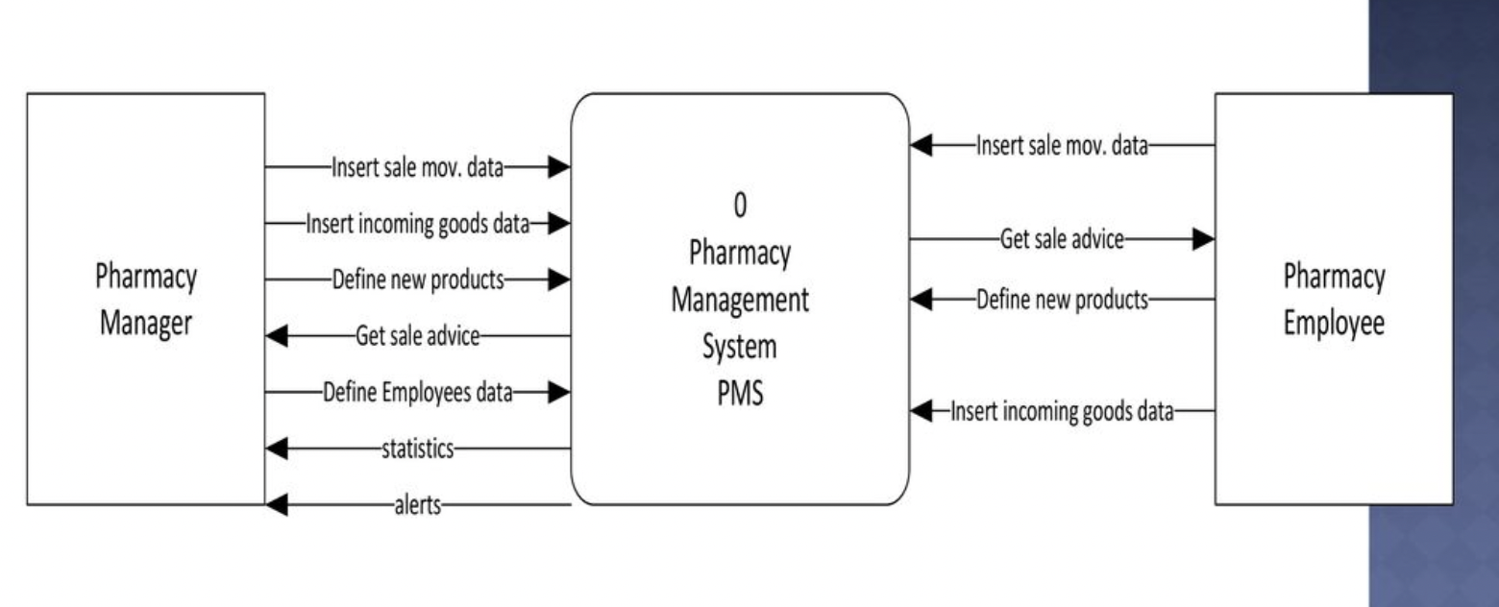

**Fig 3.1 System design**

## 3.3 PROPOSED WORK

The Pharmacy Management System is a real-time pharmacy system capable of storing patient prescriptions and date. There are two smaller windows. Pharmacy management and hospital management system. One saves the patient details and another saves the patient prescriptions.

**The Pharmacy management system is used for various purposes, including:**

* Maintaining and recording the information.
* Keep track of patients information.
* Recording prescriptions.

## 4. IMPLEMENTATION AND RESULTS

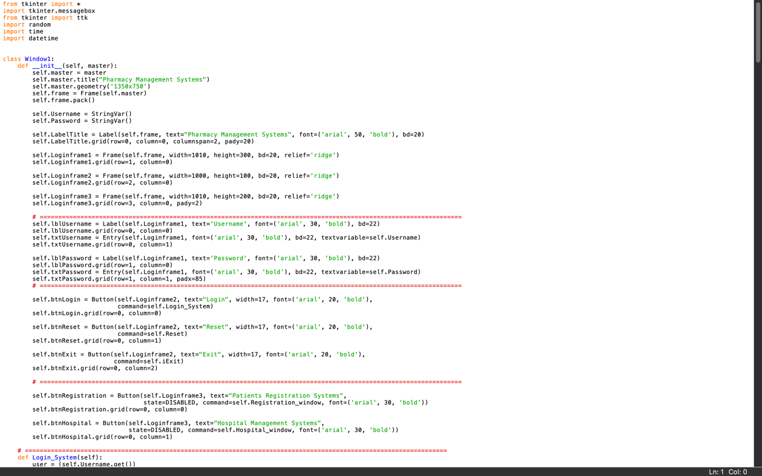

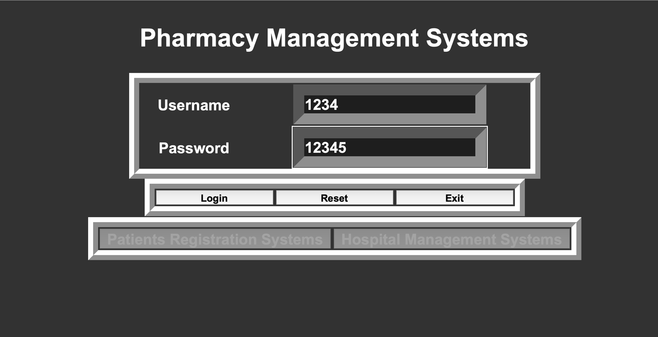

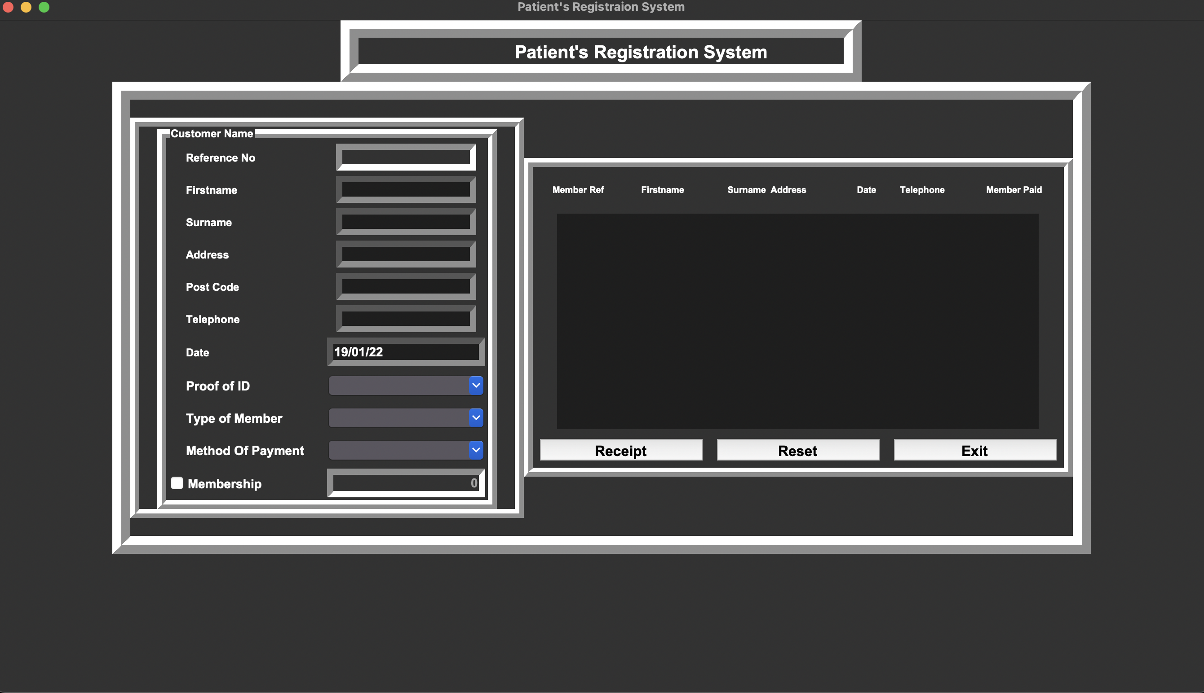

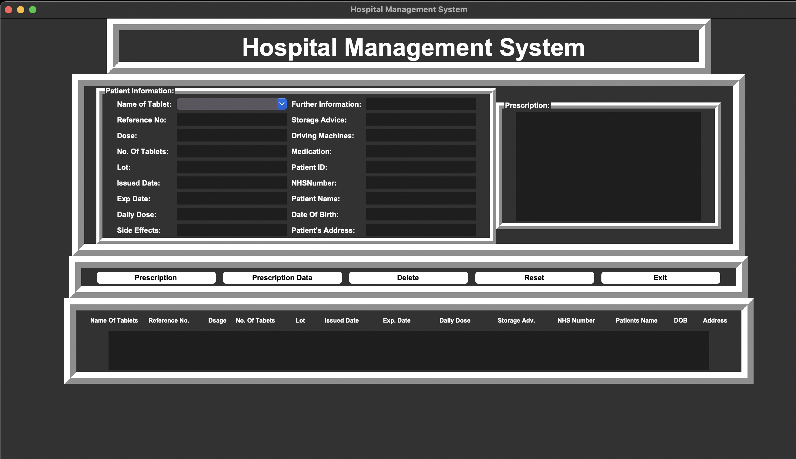

**5. CONCLUSION**

Pharmacy management system is actually a software which handle the essential data and save the data and actually about the database of a pharmacy and its management. This software helps in effectively management of the phannaceutical store or shop. It provides the statistics about medicine or drugs which are in stocks which data can also be updated and edited. It works as per the requirement of the user and have options accordingly. It allow user to enter manufacturing as well as the expiry date of medicine

placing in stock and for sales transaction. This software also has ability to print reports and receipts etc. There is other function available too. The main purpose is effectively and easily handling of pharmacy data

and its management